Details on summer picnic:
- Jaxine Harris, April 2009 -
Contact person and phone #: Parks and Recreation
Derrick @ 503-823-2525
What: Mt High group picnic! We've done 4 summers in a row since 2005 -
they should have us on record.
Where: Sellwood Park
Date: August - need to ask what weekend is available
Times: We have the park from 8am - 9pm
Space/picnic site: Ask for space "A" - this space is the largest with 9 tables
and that is the one I have always reserved.
Softball field: Reserve field "2" - that one is closest to picnic site A
You will need to pick a time to have your game - It is good
for one hour.
Cost: Last year's cost (2008) was $64 and you have to put it on a credit card
to reserve the site. The cost has gone up every year. The cost last year
breaks down as follows:
$15 for the application fee
$14 for the one hour soft ball field
$35 for park use
Everything else: They do everything over the phone. Then they send you a
packet of information, receipt, and everything you need to
know for the picnic.
You can bring your own booze.
You can BBQ - but there are rules about it.
Have fun !
Street Map of Sellwood Park
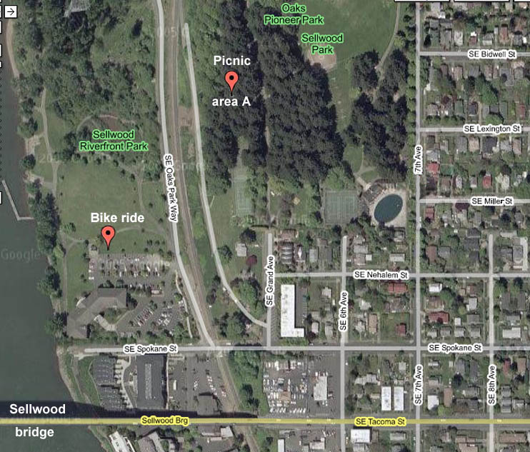
Map of Sellwood Park:
