CUSTOM PRINTED LOGO ORDER FORM
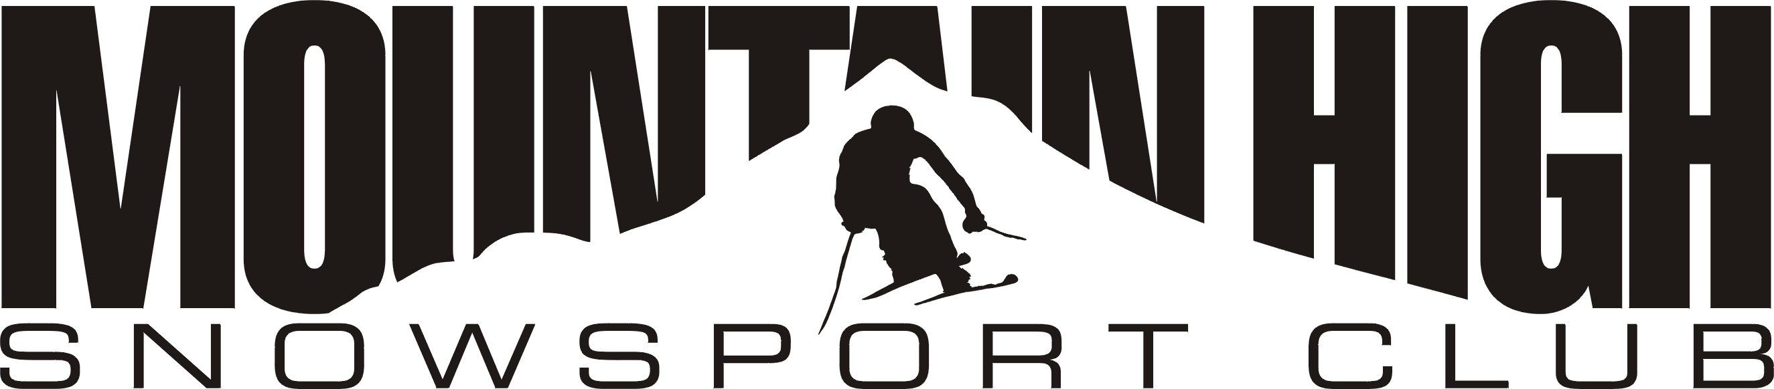 Name: _________________________________
Send order with check to:

Starbright Creations
4742 Liberty Rd. S., #296
Salem, OR 97302
Phone (503) 378-0171
Email: Starbc@earthlink.net
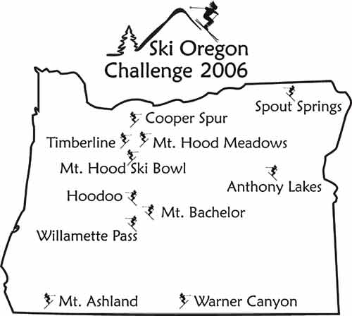
Address: _______________________________
City, State, Zip: __________________________
Phone: ________________________________
E-mail: ________________________________

Which  Logo  (Design) | Item | Color | Quantity per size:  S M L XL 2X 3X |  |  |  |  |  | Price  /shirt | Total  price
Mt.High  Ski OR  Ski WA | Mug –(15 oz.)   | Large white coffee mug, with the logo on one side. |  |  |  |  |  |  | 10.00
Mt.High  Ski OR  Ski WA | 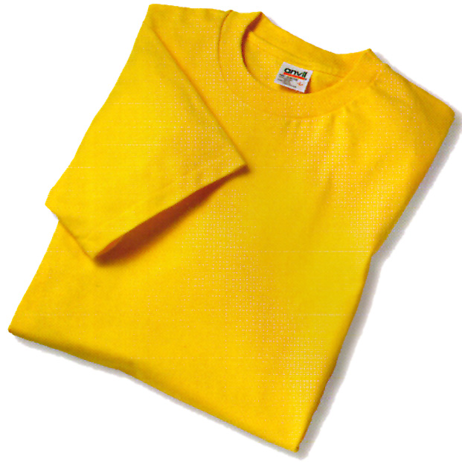  Tshirt | White  Yellow  Royal Blue  Red  Navy, Black |  |  |  |  | +1.30 | +2.00 | 10.00
Mt.High  Ski OR  Ski WA | Polo –shirts   | White  Yellow  Royal  Red  Black |  |  |  |  | +1.30 | +2.00 | 16.00
Mt.High  Ski OR  Ski WA | Polo – long sleeve | White, Red, Blue, Black |  |  |  |  | +1.30 |  | 18.00
Mt.High  Ski OR  Ski WA | Mock Turtleneck  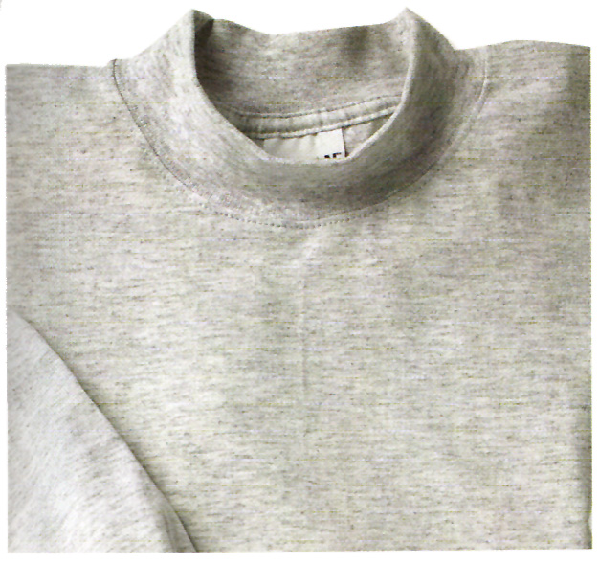 | White |  |  |  |  | +1.30 |  | 15.00
Mt.High  Ski OR  Ski WA | 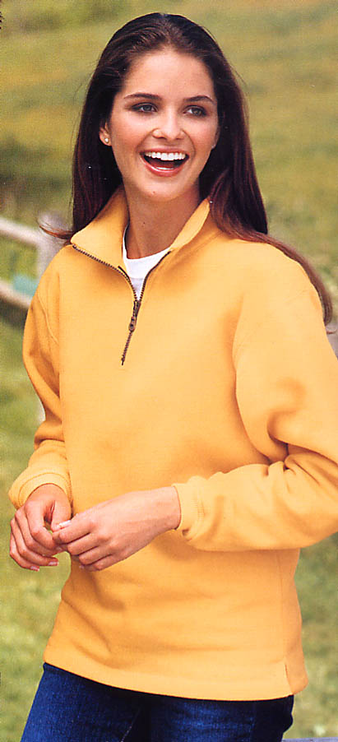  Sweatshirt  ¼ zip  cotton | Yellow  Red  Royal  Navy  Black |  |  |  |  | +1.50 |  | 25.00
Mt.High  Ski OR  Ski WA | 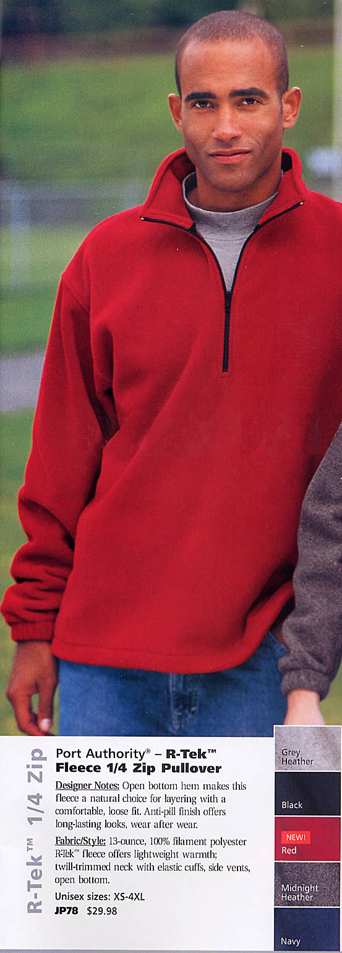  Sweatshirt  ¼ zip  R-tek  polyester | Yellow  Red  Royal  Navy  Black |  |  |  |  | +1.50 |  | 30.00
Total:
Shipping: $ 4.00
Grand Tot.:
Buyer's signature: __________________________________
Note: For each 2X shirt, add $1.30. For each 3X shirt, add $2.00. For 2X sweats add $1.50.

