Carpooling guidelines
by Emilio Trampuz
Mountain High Snowsport Club

Some of our club trips involve carpooling. Each car's occupants are free to make their own arrangements for sharing the cost of gas. But some people misunderstand the two basic ways of looking at the problem and they try to combine two different methods into one. Before a trip, chose the method to be used to pay for gas used on the trip, and make sure everyone in the car agrees.

In essence, we should count either the first fill-up or the last fill-up, but not both. For those who have a problem with that, there is also a way to avoid the issue of first vs. last fill-up altogether and simply estimate the total cost of gas needed for the trip and divide it equally among the carpoolers.

Method 1: The car rental model: Return it as found.
=============================================
Description: First fill-up doesn't count, but the last one does.
This is what the car rental agencies do. They don’t care about the fact that they paid for the first fill-up. All they care about is that you pay the last fill-up. In other words, that you return the car in the same condition as you received it – with a full tank.

How it works: In this case, the first initial fill-up doesn’t count. The last fill-up will make up for it. Now, all that counts is the gas we put into the car during the trip itself (not before the trip). The car should be returned with a full tank of gas. Add up the cost of all fill-ups, and divide equally among all.

Why not count the first fill-up? Some car owners might object to this. After all, they just put in a full tank of gas before the trip. So, why not count that? To understand why, ask yourself why the car rental agency doesn't charge you for the full tank of gas that they equipped your rental car with. If you rent a car, you would most likely consider it unfair if the rental agency charged you for the initial full tank of gas and at the same time demanded that you bring the car back with a full tank. Either the first fill-up counts or the last one. You can't have it both ways. Car rental companies choose the last fill-up method.

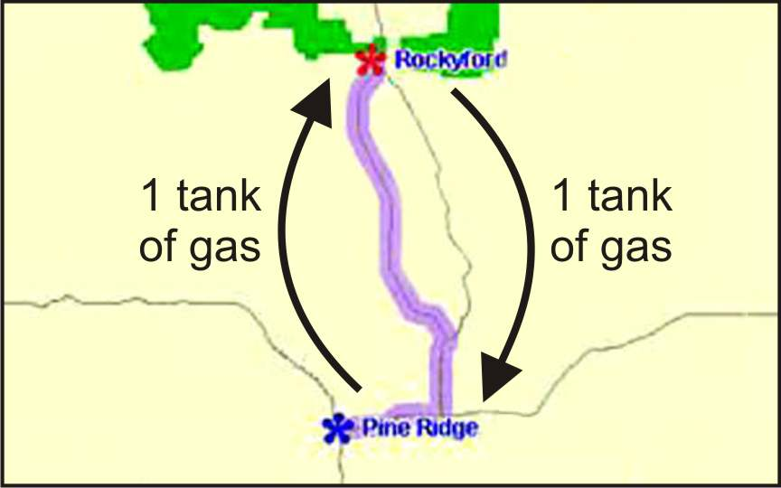
Example: In the simplest example, let's assume the carpooling destination is exactly far enough for one full tank of gas to cover the distance. The first fill up doesn't count, but the last one does. The initial full tank of gas brings the car to the destination, but so far nobody has yet purchased any gas during the trip itself. The passenger pays for a fill-up that will bring the car back home. The car's owner then pays for a fill-up at the end of the trip to bring the car back to its original state. Each has paid an equal amount for the trip. Note that the first (initial) fill-up is not counted, but the owner should have the tank full at the start of the trip.

In the end, add up the total cost of all the gas purchased, and divide equally among everyone in the car.

Method 2: Pay ahead for the miles to come.
======================================
Description: Count the first fill-up, but not the last.
This method should be used if the driver (car owner) insists that he/she has paid for the first fill-up the night before the trip and that this should be counted. But remember that under this method, the car should be brought back with an empty tank.

How it works: Count the initial fill-up, but not the last. Bring the car back with an empty tank. Any gas left in the tank at the end of the trip is pure bonus for the car owner. It is gas that the car's owner will use for future driving, unrelated to the trip. The car's owner should pay for that last fill-up himself. If his carpoolers have left him any gas at the end of the trip, he should thank them.

Example: In the simplest example, let us assume that the carpooling destination is exactly far enough for one full tank of gas to cover the distance.
The car's owner pays for the initial fill-up, which takes us to the destination.
The passenger pays for the next fill-up, which will bring the car back home.
So, at the end of the trip:
- Everyone has paid equally.
- The gas for the whole trip has been paid.
- The gas tank is empty at the end of the trip.
- Whatever gas is put into the car at trip's end has nothing to do with the trip; it's simply gas that the car's owner will use the next day for some other purpose of his/her own.

It can get a bit more complicated if there are more fill-ups or more than one passenger, but the principle is the same.

If you count the initial fill-up as contribution to the trip, then you should only count the actual gas that will return the car home. Bring the car back with an empty tank (or consider any remaining fuel a gift to the car's owner).

In the end, add up the total cost of all the gas purchased, and divide equally among everyone in the car.

The wrong way
=============
It would be incorrect and unfair to try to combine these two methods into one, to try to count the first fill up and at the same time to demand that the car be returned with a full tank of gas. This would be a boon to the car's owner, but it would be unfair to the passengers.

If anyone has a problem understanding why either the first or the last fill up should be counted but not both, then try using the third method, which works around this issue.

Method 3: Just the mileage
========================
This method avoids the whole first/last fill-up issue.
Description: Compute the total miles for the trip, and divide this by the car's miles per gallon, to get the number gallons needed for the trip. Then multiply that by the average cost of a gallon of gas to get the total cost of the gas.

This is an approximation. It might not be as accurate as the other two methods, but it does clarify things. The method produces a single number: the total cost of gas for the trip. Then simply divide that cost equally between all the carpoolers.

Example: Let's say the total distance for the round trip is 1,200 miles. A car that gets 22 mpg will consume 54.54 gallons. At an average of, say, $3.85 per gallon, that would be a total of $210 for the whole trip.

Finally, divide the cost of gas ($210) equally among all the carpoolers. If there are just 2 people in the car, each would pay $105. If there are 3 people, each would pay $70. If there are 4 people, each would pay $52.50.

Even though this may be just an approximation, it will give you a ball-park figure that can be adjusted as needed. The best thing is that this method avoids the whole issue of first and/or last fill-up. It just looks at the total cost of gas, as computed from the mileage covered. Use this method to double-check the accuracy of any of the other methods you may have used, and to make sure that everyone has paid an equal amount.

Wear and tear on the car
======================
It could be argued that wear and tear on the car should be taken into account too, and that therefore the driver should pay less. That's fine, if that's what the passengers agree to. But, in most cases, the cost of gas is shared equally.

The wear and tear on the car is a real factor, but it is not normally taken into account for several reasons:

1. The driver volunteers his/her own car.
2. The driver gets the best seat in the car – the most comfortable one.
3. The driver gets his/her own environment, which is almost always more comfortable than being in someone else’s car. The driver gets his own cup-holder, personal storage space, his/her own music, gadgets, maps, emergency medicines, etc. There is simply a greater level of comfort for the driver, and that is the main reason why many people prefer to offer their own car for carpooling trips.

The benefits of being the driver/owner of the car offset any disadvantage from the car's wear and tear.

The thing to remember, if you are looking to equally split the cost of the actual gas used during the trip, is that you need to count either the first fill-up or the last one, but not both.

AN ILLUSTRATION OF HOW
FIRST/LAST CAN BE MISUSED
===========================

Here's a little anecdote that illustrates this whole issue of first vs. last fill-up. It's about a scam shown in an old movie, where these two pirates find some treasure, some coins, and they decide to split it evenly between the two of them. The guy doing the splitting is the savvy one and he takes advantage of the other guy by making frequent pauses in the counting, and after each pause, he always starts by giving himself the first coin and also always ends by giving himself the last coin. Let’s say the two guys are TOM and JERRY. Tom does the counting, and as he moves one coin at a time, he counts:

TOM: 1 for me, 1 for you, 1 for me. (Pause)
Notice that TOM counted himself 2 coins, while JERRY got only one.
Now they talk about something else for a while, as a distraction tactic. Then they continue:
TOM: 1 for me, 1 for you, 1 for me, 1 for you, 1 for me. (Pause)
Now Tom has dealt himself 3 coins, while Jerry got only 2.
Then they pause to drink some rum.
The counting continues with Tom always taking both the first and the last coin.

This little episode just illustrates how it’s wrong to count both the first and the last of anything. It’s one or the other, but not both.

Now, armed with this knowledge, go ahead and enjoy your trip.
Happy carpooling!

