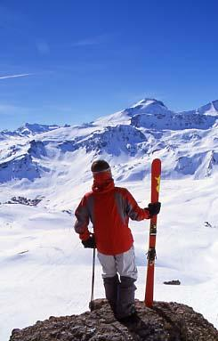

Join us for a week of skiing and boarding in the French Alps!
The world famous "Espace Killy" (Val d'isere/Tignes) offers one of the largest ski areas in the world
at a great price!

- Round trip air Portland-Geneva and bus Geneva-Val d'Isère
- 8 nights lodging (breakfast incl. double or triple occupancy)
- 6-day lift pass at L'Espace Killy.*
- Beginners and seniors 75+ ski for FREE!
- Ski/mountain/repatriation insurance

* 6 day pass includes a bonus day pass at La Plagne-Les Arcs, Trois-Vallées, or Valmorel, as well free heated indoor swimming. Other pass options available upon request at time of booking.
Other sports and leisure options: Initiation to driving a team of husky dogs; Ice racing (quad-bikes, karting); Para-gliding; Hang-gliding; Climbing wall; Sauna; Steam room; Jacuzzi; Massages, etc.

