

SKI OREGON CHALLENGE

Gear up for a new Northwest Council event, The Ski Oregon Challenge. The Council Board is challenging Northwest skiers to ski or board nine of Oregon’s eleven ski resorts during the 2005-06 ski season and qualify for the Council’s year end drawing for prizes – equipment, services, 2006-07 lift tickets and a ten-time punch pass at Mt. Hood Meadows. Turn in proof that you have skied nine of the Oregon ski resorts listed below and your name will be entered in the drawing. Ski all eleven areas and you qualify for a special award. Proof can be lift tickets from each ski resort or a credit card receipt showing proof of purchase. Entries and proof of qualification must be received by the council no later than June 15, 2006. The drawing will take place at the June council meeting. You must be 18 years old or older to enter.

You may ski or board at the designated ski resort at any time during the 2005-06 ski season. If you are a PACRAT racer you can use your lift tickets for each day that you ski and race at the ski resorts as proof. Many clubs have trips scheduled to these areas during the season.

• Anthony Lakes  • Cooper Spur  • Hoodoo  • Mt. Ashland  • Mt. Bachelor  • Mt. Hood Meadows  • Mt. Hood Ski Bowl  • Spout Springs  • Timberline  • Warner Canyon  • Willamette Pass | 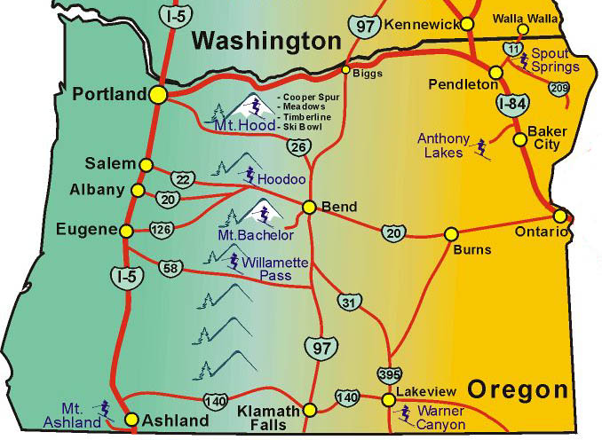

The Entry Form and Rules are posted to the NWSCC website at www.nwskiers.org.

For more information contact:
Steve Coxen
Phone: 503-679-9022
Email: sacoxen@aol.com

To enter, complete this form and include it with your proof documents. Documents must be received no later than June 15, 2006. We recommend that you keep copies of the documents. Submit documents to the address below:
NWSCC Ski Oregon Challenge
PO Box 1915
Portland, OR 97207

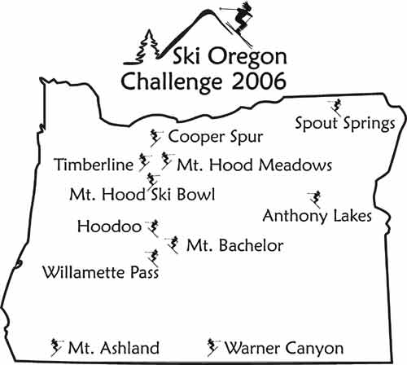

You can order the above design printed on the backs of shirts, while the top part (the logo) is printed on the front left chest (pocket seized). Or, if you prefer, just the logo in the front.

The price of the printed items is:
  Cotton for comfort | 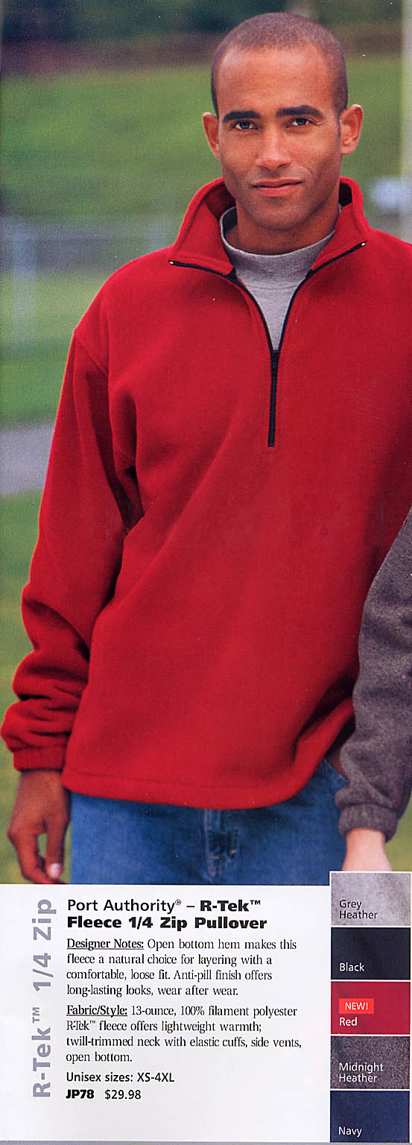  R-tek fleece for active sports
T-shirts: $7.50
Short sleeve polos: $13
Long sleeve polos: $16
Long sleeve mock turtlenecks: $12
Cotton sweatshirt (1/4 zip fleece): $20
R-tek polyester ¼ zip sweatshirt: $25

Colors available:
White, Yellow, Ash gray, Red, Blue, Navy, Black.

Sizes: Small – XXL

To order:
Specify color, size, and quantity,
and make check payable to
“Starbright Creations”. Mail to:

Emilio Trampuz
4742 Liberty Rd. S., #296
Salem, OR 97302.
Phone: 1-503-378-0171
Email: Emilio2000@earthlink.net

SKI OREGON CHALLENGE
ENTRY FORM

Name of Participant______________________________________________

Member of Club (not required)______________________________________
Phone number_______________________________
Email address______________________________________

Indicate dates skied at Oregon ski resorts below. Attach proof to this entry form. Proof must be the lift ticket used or a credit card receipt for the purchase of the ticket. You must be 18 years old or older to enter.

DATE
- Anthony Lakes __________________
- Cooper Spur __________________
- Hoodoo __________________
- Mt. Ashland __________________
- Mt. Bachelor __________________
- Mt. Hood Meadows __________________
- Mt. Hood Ski Bowl __________________
- Spout Springs __________________
- Timberline __________________
- Warner Canyon __________________
- Willamette Pass __________________

To enter, complete this form and include it with your proof documents. Documents must be received no later than June 15, 2006. We recommend that you keep copies of the documents. Submit documents to the address below:

NWSCC Ski Oregon Challenge
PO Box 1915
Portland, OR 97207

