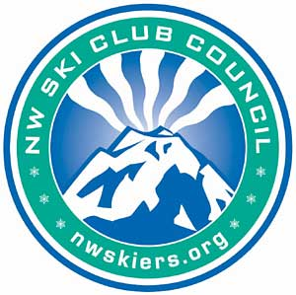

SKI THE NORTHWEST CHALLENGE

You can participate in this unique Northwest Council challenge, to ski or snowboard a minimum of 7 ski areas anywhere in Oregon or Washington, and certain areas in Idaho, Montana, Wyoming, or British Columbia in a single season. At the end of the season, mail in your lift tickets or credit card receipts or photocopy of a current season’s pass showing proof of purchase of lift tickets. Entries and proof of qualification must be received by the Council no later than June 15. The drawing will take place in the fall of the year of entry. You must be 18 years old or older to enter.

The names of all who meet the minimum of 7 resorts visited will be posted on our website, ranked by the number of total resorts. Everyone who completes this challenge will qualify for the Council’s year-end drawing for prizes – equipment, services, and lift tickets for the following season. The more resorts you visit, the more valuable prizes you will qualify for.
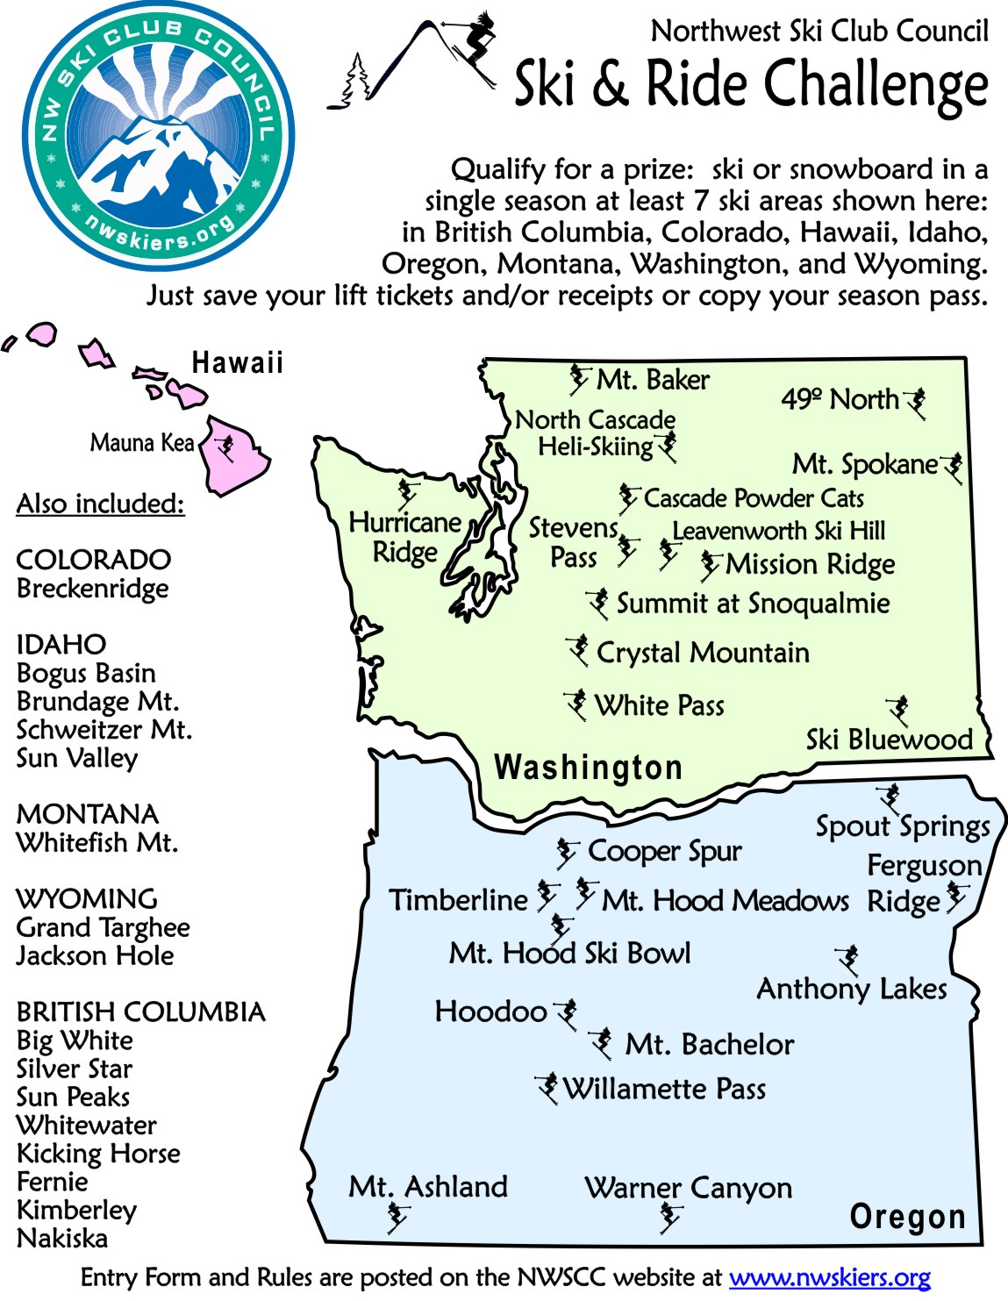

The Entry Form and Rules are posted on the NWSCC website at www.nwskiers.org.
A visit to any ski area listed here qualifies.
To enter, you must print out and complete the form on the following page and include it with your proof documents. Documents must be received no later than June 15. We recommend that you keep copies of the documents. Submit documents to the address below:
Northwest Ski Challenge
c/o NWSCC
5331 SW Macadam Avenue, Suite 258, Box 438
Portland, OR 97239
For more information contact NWSCC at contact@nwskiers.org.
NORTHWEST SKI CHALLENGE
ENTRY FORM

Name of Participant______________________________________________

Member of Club (not required)______________________________________
Phone number_______________________________
Email address______________________________________

Indicate dates skied at each ski resort below. Attach proof to this entry form. Proof must be the lift ticket used or a credit card receipt for the purchase of the ticket or a photocopy of a current season’s pass. You must be 18 years old or older to enter.

OREGON DATE
Anthony Lakes ______
Cooper Spur ______
Ferguson Ridge ______
Hoodoo ______
Mt. Ashland ______
Mt. Bachelor ______
Mt. Hood Meadows _____
Mt. Hood Ski Bowl _____
Spout Springs ______
Timberline ______
Warner Canyon ______
Willamette Pass ______

BRIT. COLUMBIA DATE
Big White ______
Silver Star ______
Sun Peaks ______
Whitewater ______
Fernie ______
Kicking Horse ______
Kimberley ______
Nakiska ______
WASHINGTON DATE
Cascade Pwder Cats __
Crystal Mt. ____
49 Degrees North ____
Hurricane Ridge _____
Leavenworth Ski _____
Loup Loup _____
Mission Ridge _____
Mt. Baker _____
Mt. Spokane _____
N. Cascade Heli _____
Ski Bluewood _____
Stevens Pass _____
Summit at Snoqualmie _____
White Pass _____

IDAHO DATE
Bogus Basin _____
Brundage Mt. _____
Schweitzer Mt. _____
Sun Valley _____
MONTANA DATE
Whitefish Mt. ______

WYOMING DATE
Grand Targhee ______
Jackson Hole ______

COLORADO
Breckenridge ______

To enter, complete this form and include it with your proof documents. Documents must be received no later than June 15. We recommend that you keep copies of the documents. Submit documents to the address below:

NWSCC Ski Oregon Challenge
5331 SW Macadam Avenue, Suite 258, Box 438
Portland, OR 97239

