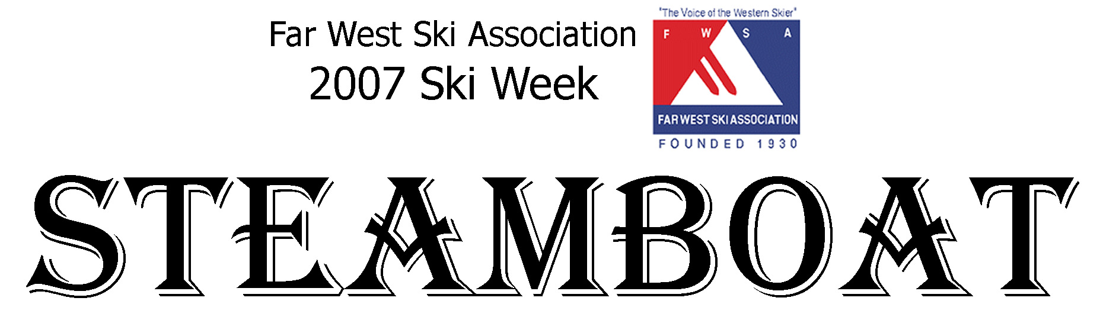
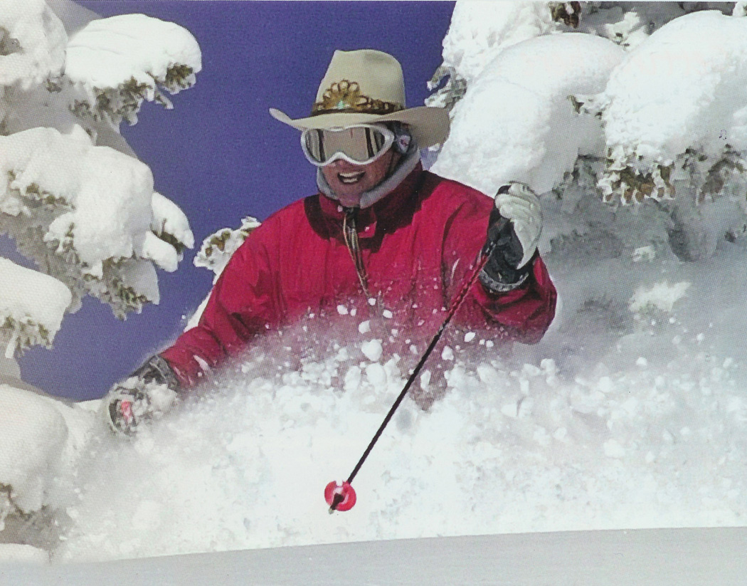
January 27 – February 3, 2007

Located in the Colorado Rockies, Steamboat Ski Resort has 143 trails, 3,600 vertical feet, and nearly 3,000 skiable acres. Steamboat provides a variety of terrain for every level of skier. Steamboats six peaks are filled with groomed cruisers, bumps, steep, open meadows and legendary tree skiing.

The phrase "champagne powder snow" was coined at Steamboat. During the 2004-05 season, Steamboat invested over $1 million improving their chairlifts. It has a total of 20 lifts including an 8 passenger gondola and high speed quads.

The price for NWSCC participants has not yet been finalized but it will be about $850, not including air and ground transportation. We are limited to 62 spots. This includes 7 nights lodging (double occupancy) and the FWSA amenity package. Lodging will be at The Lodge at Steamboat, located just 200 yards from the gondola. The Lodge provides a private shuttle to skiing, dining, etc.

The FWSA amenity package includes: Welcome Party, Apres Ski Party, Mountain Picnic, 3 Races, Farewell Awards Party and 5 of 7 day Lift Tickets.

Plan now and reserve your spot by making a $100 deposit! Your deposit is fully refundable until June 30th. Payment Schedule: July 1st – $250 due, September 1st - $350 due and November 1st – remaining balance due.

Trip cancellation policy: Cancellation from July1st until September 1st will result in a $25 cancellation fee, cancellation between September 2nd and November 15th will result in a $100 cancellation fee. NO REFUNDS after November 15th.
Please make your checks payable to: Northwest Ski Club Council, P.O. Box 1915, Portland OR 97207

For More Information Contact: Rod Robinson at (541) 344-7170 or rdrobinson@aol.com

